IMPORTING CSV FILES INTO EXCEL WITHOUT LOSING PRECISION

Any column that contains large numbers, or values that could be read as large numbers, must be read into EXCEL as text in order to avoid rounding and scientific notation. Follow the steps below to import the CSV into EXCEL and format those columns as text at the time of import.

**STEP 1**

Open Excel and on a blank worksheet select the **DATA** tab at the top

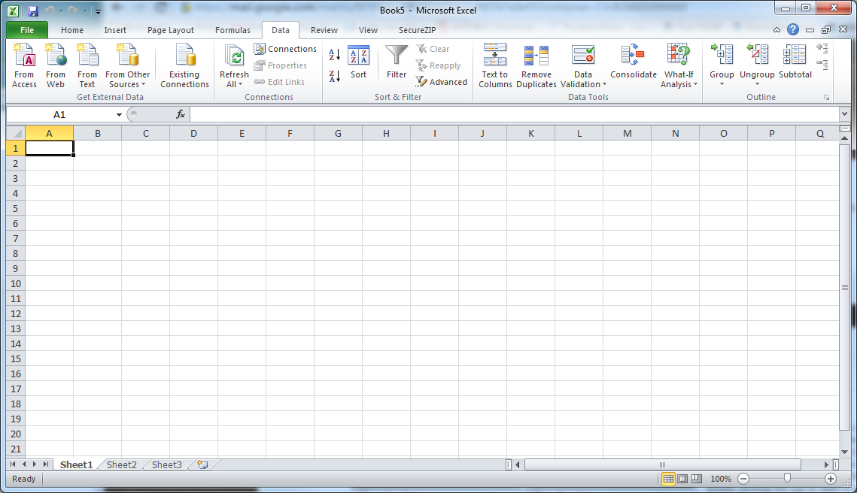

**STEP 2**

Select the ***FROM TEXT***button under the ***GET EXTERNAL DATA*** section



**STEP 3**

In the ***Import Text File***window that opens, navigate to the CSV file you wish to import and select ***IMPORT.***

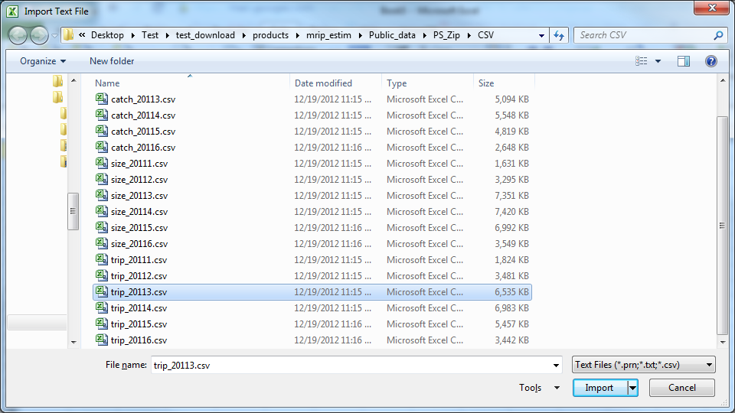

**STEP 4**

In The ***Text Import Wizard*** click ***NEXT*** on step 1 of 3.

**STEP 5**

For step 2 of 3 in the ***Text Import Wizard***, change the delimiter to **COMMA** and the text qualifier to **{NONE}**. Click ***NEXT*** when finished.

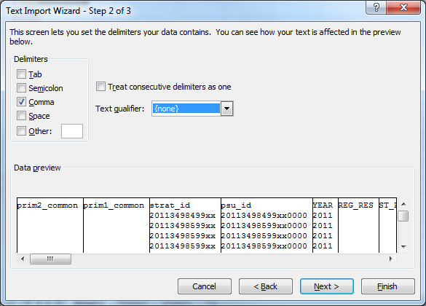

**STEP 6**

For step 3 of 3 in the ***Text Import Wizard***, change the **COLUMN DATA FORMAT** to **TEXT** for each column that is losing precision. To do this, using the scroll bars in the **DATA PREVIEW** click on the column you wish to edit and then select the new data format. Note, the current data format is listed above the column name for every column. These must be changed individually.

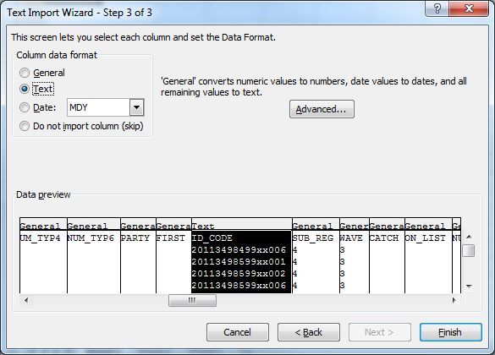

**STEP 7**

Click **FINISH** when done, **OK** on where to import to, and confirm your values have not been rounded

